
AMERICAN INTERNATIONAL UNIVERSITY-BANGLADESH
Faculty of Science and Technology
Department of Computer Science
CSC 3215: Web Technologies

Semester: Summer 2025-26 | Group No: 10 |  | Section: | AA

Group Members:
SL. | Student ID | Name | Role | Signature
1 | 22-48300-3 | Utsho,Md.Ahosan Habib | Group Leader
2 | 22-47005-1 | Md.Shafin Islam | Member
3 | 22-46715-1 | Mim Akter | Member
4 | 24-57223-2 | Fahim Shahariar | Member
Project Title
RestoFlow (CraveCart) - A Comprehensive Food Ordering and Delivery Management System
Short Description
RestoFlow is an MVC-based web application developed using PHP and MySQL that facilitates seamless food ordering, restaurant inventory management, and delivery tracking. It connects four distinct types of users—Customers, Restaurant Managers, Delivery Riders, and System Admins—into a single, unified platform, featuring real-time data handling via Ajax/JSON and robust PHP/JS validations.
Introduction
The food service industry increasingly relies on digital platforms to connect hungry customers with local restaurants and efficient delivery personnel. RestoFlow (CraveCart) is a custom-built web technology solution designed to streamline this entire lifecycle. Utilizing a custom MVC architecture, procedural MySQL database connections, and session-based authentication, the system provides dedicated, secure dashboards for every stakeholder. By emphasizing feature separation and strict role-based access, RestoFlow ensures that order processing, inventory updates, and revenue tracking are handled securely and efficiently.
Background Study
Currently, many small to medium-sized restaurants struggle with disjointed systems where order taking, delivery dispatching, and revenue tracking are handled manually or across incompatible software. This leads to delayed deliveries, stock mismanagement, and poor customer satisfaction. RestoFlow was conceptualized to solve this by providing an integrated, centralized web platform. It eliminates overlapping responsibilities by giving each actor isolated tools tailored strictly to their specific workflow. Implementing this system improves operational efficiency, establishes accountability through distinct user roles, and enhances the overall user experience.

ER Diagram
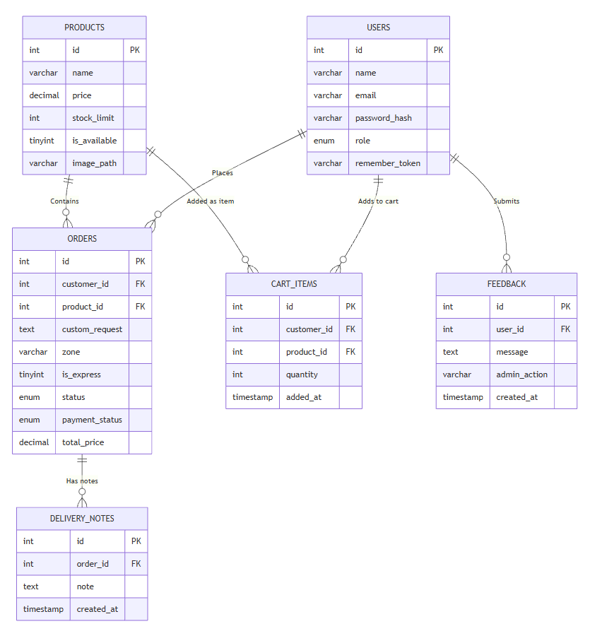

Use Case Diagram
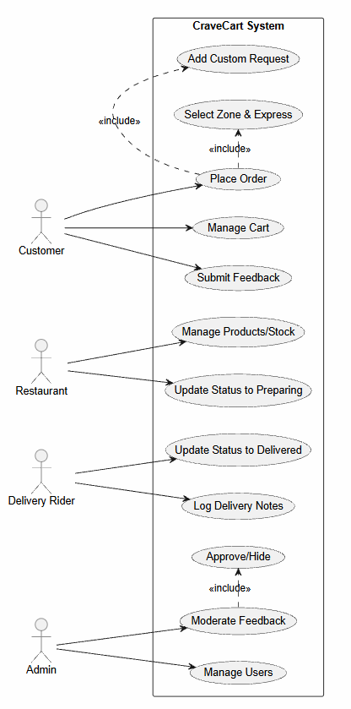

UI (Figma/Sketch)
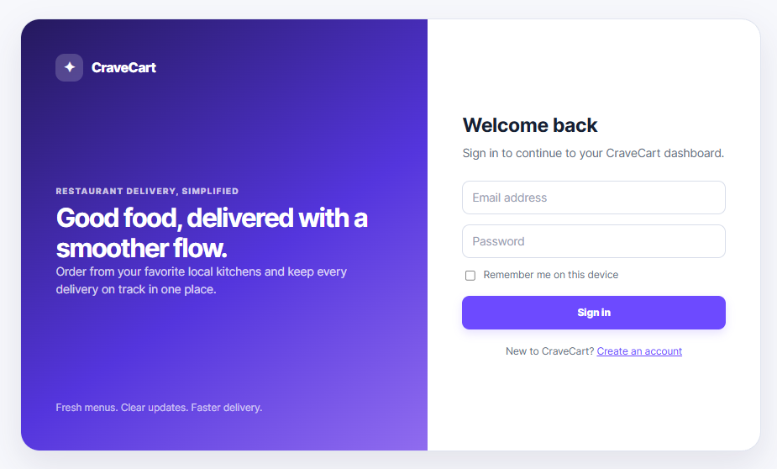
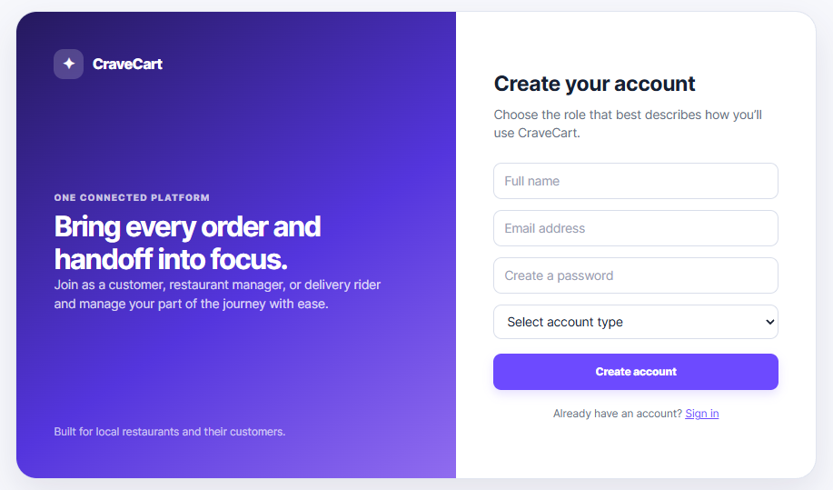

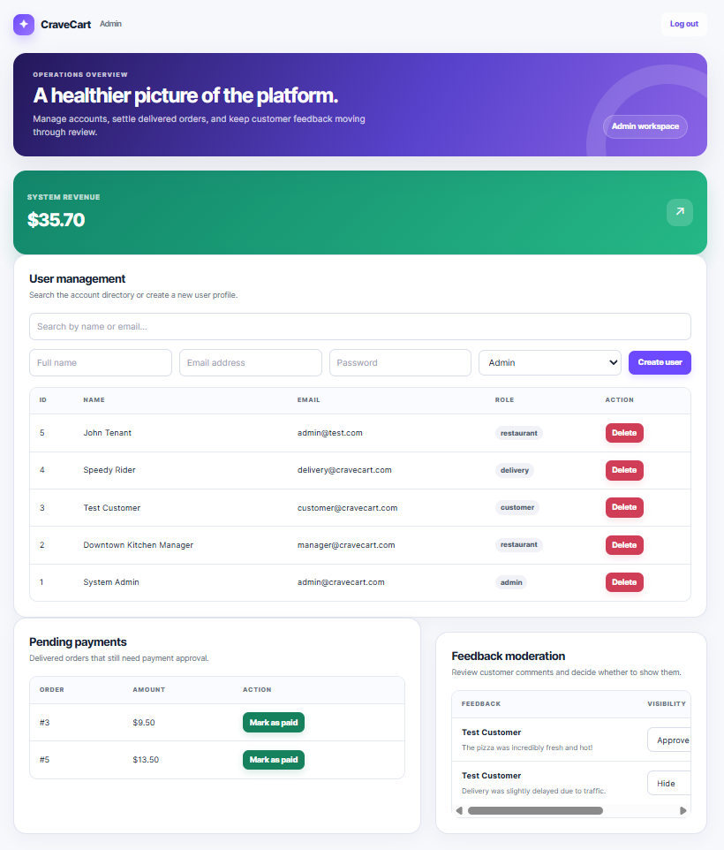

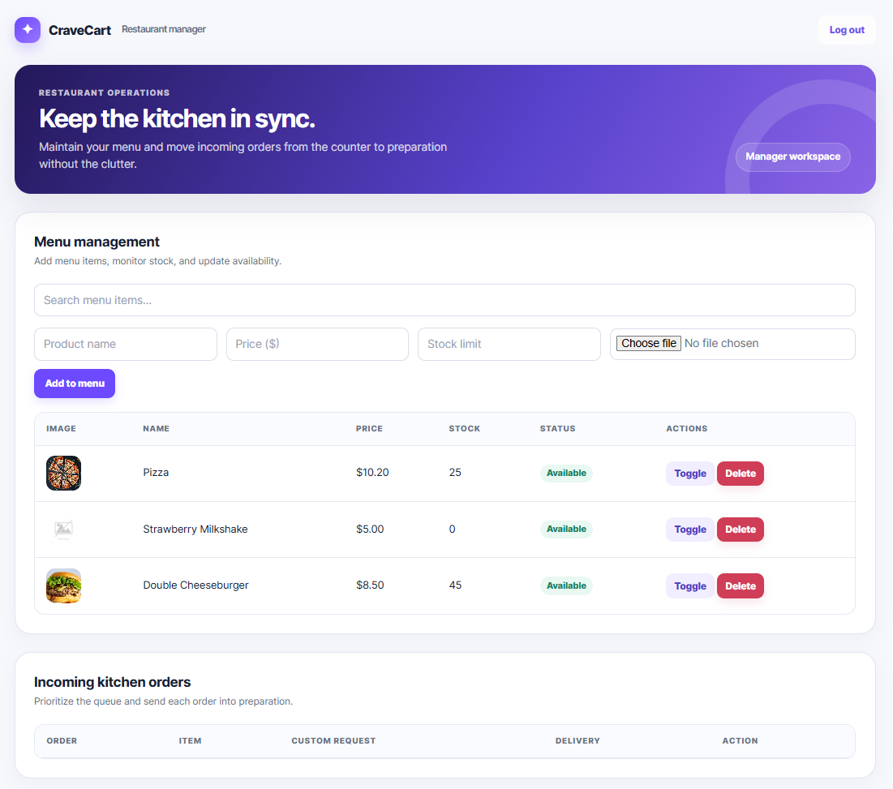

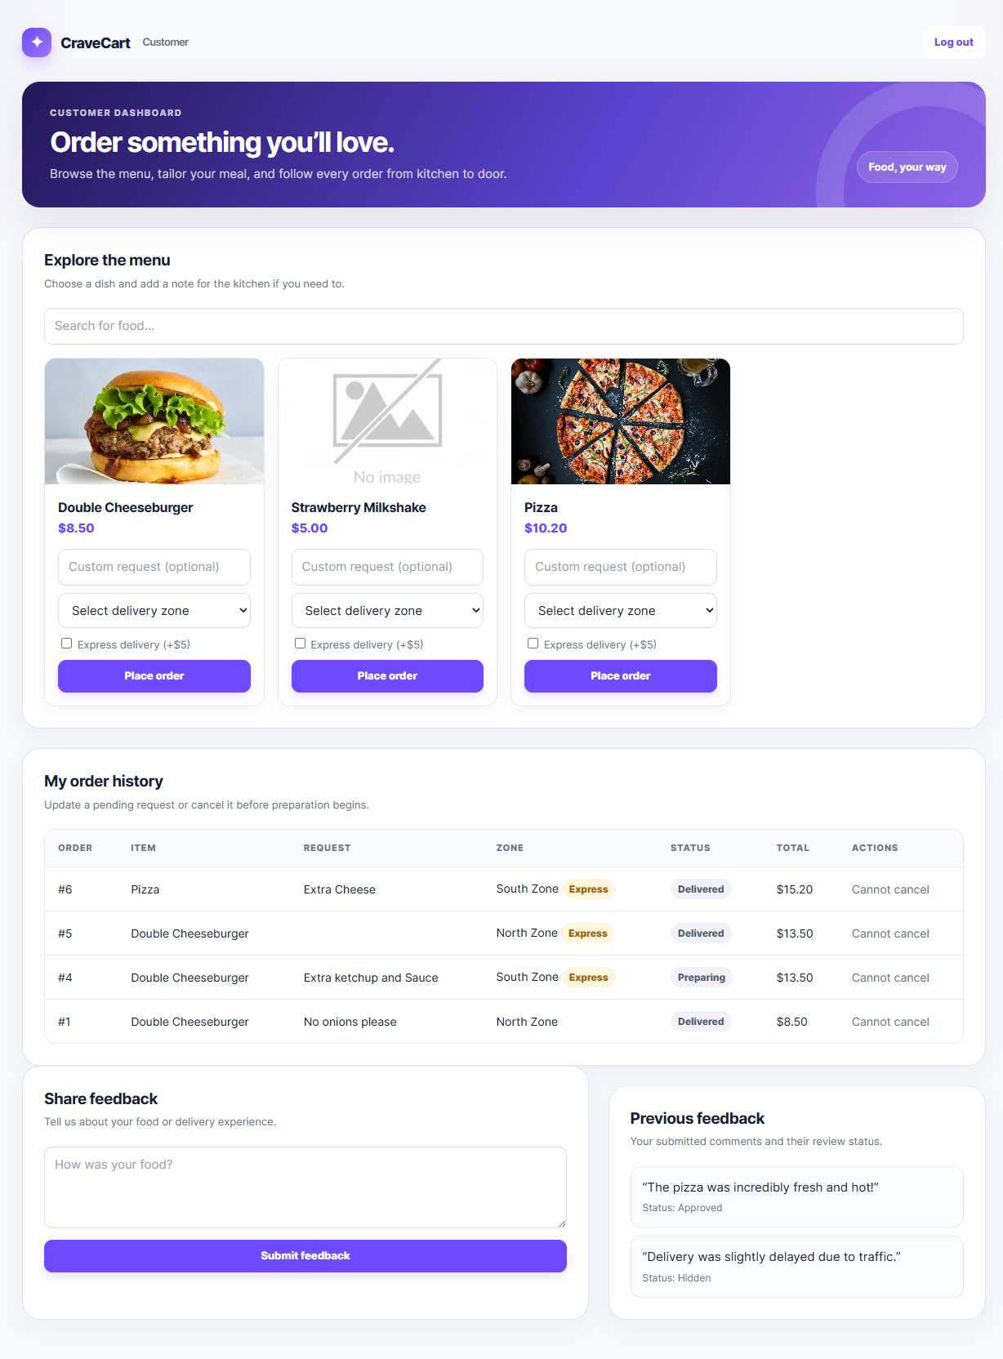

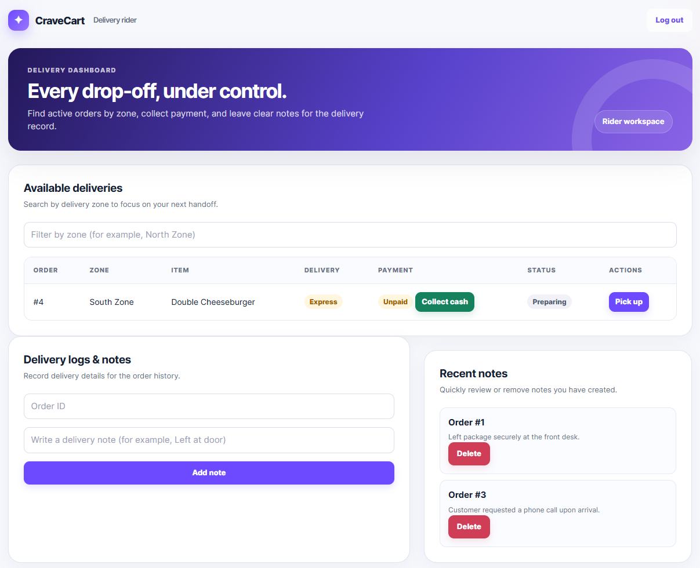

Types of Users: 1. System Admin 2. Restaurant Manager 3. Customer 4. Delivery Rider
Common Features (Available to All Users)
- Authentication
- Login to the system
- Logout from the system
- User registration
- Account Management
- Change or reset password
- Manage profile information (view, edit, delete)
- Dashboard
- Access a personalized dashboard after login
Specific Features by User Type
- Features of System Admin
- View Total System Revenue (track and aggregate total_price across delivered orders).
- Approve Order Payments (manage financial tracking via the payment_status column).
- Moderate Customer Feedback (evaluate reviews and update admin_action to Approved or Hidden).
- Perform full CRUD and Search operations on the User Management module via Ajax.
- Features of Restaurant Manager
- Manage Stock Limits (adjust the stock_limit integers for individual menu items).
- Toggle Product Availability (flip the is_available boolean to hide/show items to customers).
- Update Order Status (transition incoming orders from 'Pending' to 'Preparing').
- Perform full CRUD and Search operations on the Products inventory.
- Features of Customer
- Add Custom Food Requests (append specific text instructions like "No onions" to the custom_request column).
- Request Express Delivery (toggle the is_express flag during the checkout process).
- Submit Restaurant Feedback (write and post messages to the feedback table for admin review).
- Perform full CRUD operations on their personal Cart Items and Orders.
- Features of Delivery Rider
- Filter/View Deliveries by Zone (sort the orders table by matching the zone attribute).
- Update Order Dispatch Status (transition assigned orders to 'Out for Delivery' and eventually 'Delivered').
- Add Delivery Notes (create specific text records in the delivery_notes table for tracking drop-off details).
- Perform Search and Read operations on the assigned delivery queue.

N.B: Each user type must have at least 3 distinct features different from the others. Additional features may be added if desired. Proposals with generic, incomplete, or duplicated features across user types will receive reduced marks under the criteria below.

